Panopto Quick Start Guide

Panopto Assignment Folder: Setup guide for Staff

The Assignment folder is a special folder in Panopto designed to provide students with the facility to record and upload video content into Sulis. The process of setting up an assignment folder is straightforward. There are however a few things to be aware of:

- This feature of Panopto is not a comprehensive assignment tool – it’s only providing a simple location where students can upload video content. There is no deadline feature and you cannot grade videos or leave feedback directly in Panopto. You must use Panopto Assignment folders in conjunction with your existing assessment practices:

- Related to the above, students can re-submit and edit and delete videos with no deadline or cut-off date. So to prevent students’ re-submissions and editing after the deadline you will manually have to close the assignment folder.
- Students can upload multiple videos to Panopto Assignment folders, which can be handy for multi-component submissions or where students record multiple ‘takes’ before deciding on a final version. But this could be a cause of confusion during marking. Instruct students to decide on a final version and delete all others by the deadline, or to use appropriate file naming. Ideally they should also include their name in the title (although there is a way identified below to show author).

- By default, students are unable to view each other’s work, but you as a tutor can see all submitted videos. If required, you can open up access so all students (see section below) but it is recommended you let students know this before you do it.

Step 1: Setting up the Assignment Folder

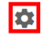
- Log into Sulis, browse to the site where you wish to create the assignment folder. Click on the Panopto link from the tool menu.
- Click on the Folder Settings button (cog) on the right-hand side

- Within the Settings window click on the Create Assignment Folder link

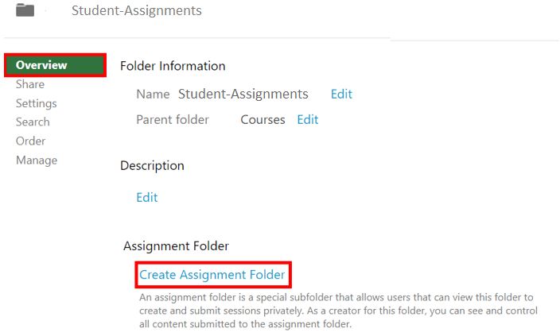

This will create an assignment folder for your module.

Information: The student workflow

We have created a guide to Panopto for student on ITSS student website. The link to the site is as follows https://ulsites.ul.ie/itd/node/127271
Please direct students to this site if they require further information on using Panopto.

- To create or upload a recording to the assignment folder students will launch the Panopto tool from within Sulis.

- The student will then click on the Create button, and can choose to:
              - A. Record a new session using the Panopto Recorder
              - B. Record using Panopto Capture
              - C. Upload their video using the Upload media tool.
- If a student chooses to “Record a new Session” this will give students the ability to install and launch the Panopto Recorder. Students will only be able
to record to the Assignment Folder created above. If students have previously installed the Panopto Recorder software tool they can launch this directly and start recording.
Student can also use the Panopto Capture tool to create recordings.

- The Upload media option will provide students with a window through which students can upload a pre-re-corded video file to the Assignment Folder.
- UL registered students are also able to record directly to the folder using the Panopto app for Android and Apple iOS devices, using their UL credentials.
- Once their videos are uploaded to the Assignment folder, students can playback, edit and delete any of their uploaded videos. They can also create or upload further videos, so you need to manually close the assignment folder after the video submissions deadline has passed. Remember, by default they will only be able to see media that they themselves have uploaded.

Allowing students to see each other’s submissions

This could be a useful tool if you would like other students to see and learn from each other’s work. Please advise students of this prior to changing this setting.

- Go to the Panopto area of your course then click on the link to take you to the Assignment folder

- Here click on the Settings cog on the right

- Go to the Settings tab on the left

- Tick the checkbox for ‘Allow viewers to see each other’s sessions’.

- Click on the Close button
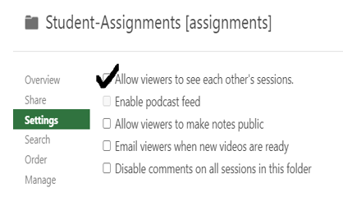

What to do on the submission deadline

To prevent students uploading or editing their videos after the submission deadline has passed you will need to close the assignment folder.
To Close the Assignment folder, simply navigate to the parent folder of the assignment folder, click the setting button and Press Close.

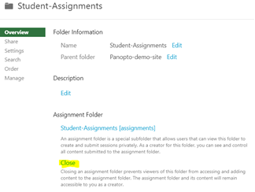

Advice regarding managing Submissions

Please note, video files tend to be large in size and depending on the student’s broadband connection they may take a significant amount of time to upload their video submission. This should be borne in mind when setting video assignment deadlines.
A suggested option to manage late submissions is to maybe close the Assignment Folder at the deadline but create a late Assignment folder to allow students who may for genuine reasons have missed the deadline still receive some credit for their work.

